CABIN Sites: Good Hope Lake Area

July 17, 2020

**McDames Tributary Site 1: 59 14.148 -129 16.880 Suggested Site**

Upstream 50m

Looking upstream

**McDames Trib by Culvert and road access, Site 2: 59 14.205 -129 16.617**

**Proposed site**

Looking down stream Looking upstream

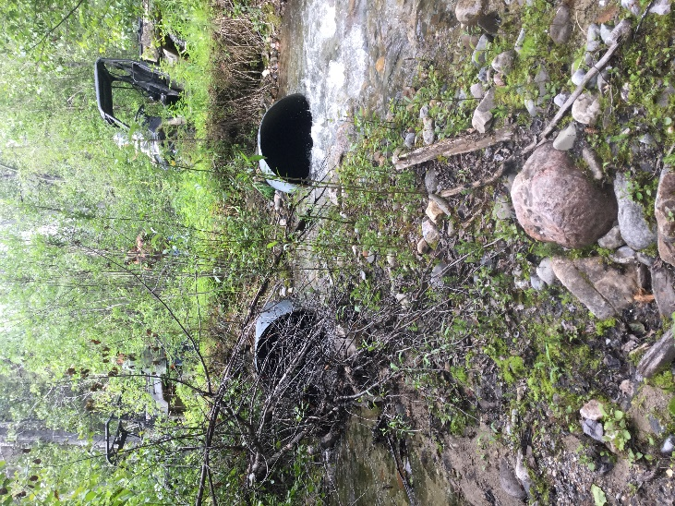 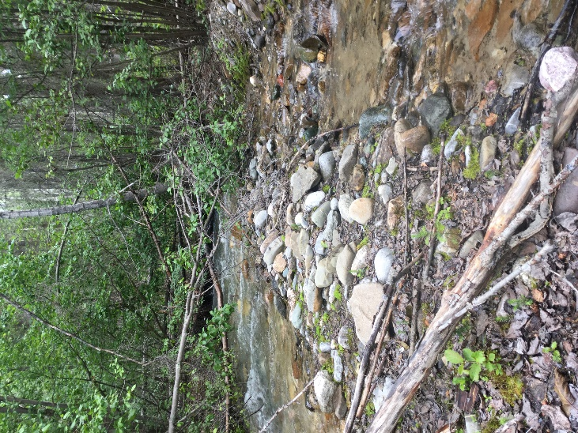

**Dease River Trib: 59 10.425 -129 15.007**

**Suggetsed Site**

Road access to the Dease River then had to access site by boat 1.5km up the Dease River. Site was about 100m upstream.

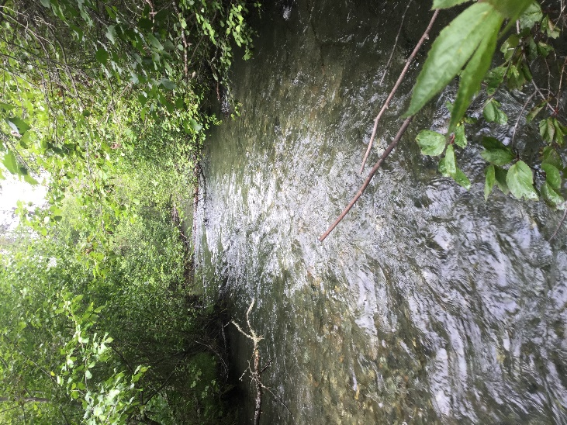 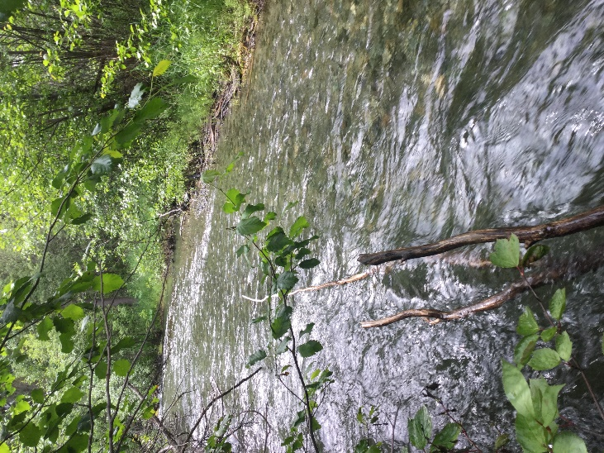

**Charlie Chief Creek Site 1: Site 1 59 25.192 -129 10.922 Proposed SIte**

8m upstream from culvert and highway, there was a small drainage flowing into the creek just before suggested sample site, very grown in around this are and covering creek

Drainage flowing into creek Looking upstream drainage comes in from the left

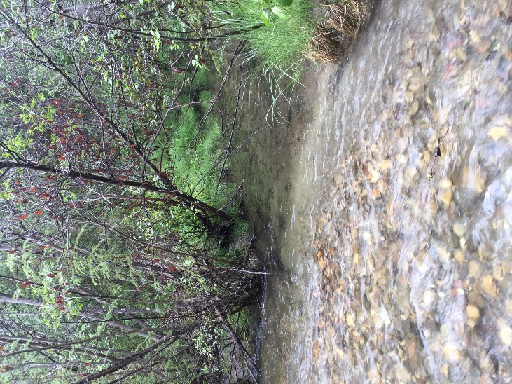 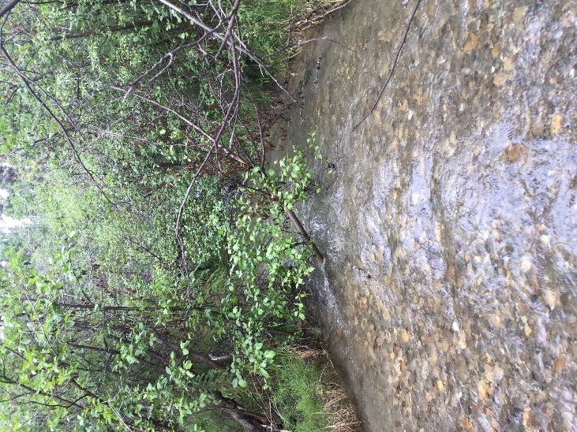

Looking downstream

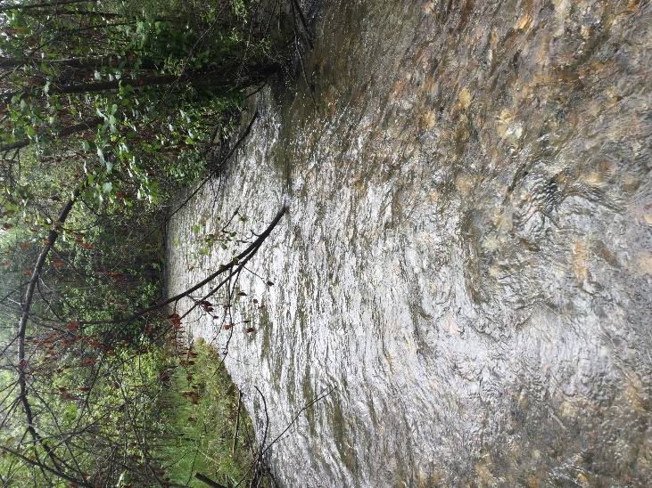

**Charlie Chief Creek Opposite side of highway downstream, Site 2: 59 25.223 -129 10.847**

50m downstream from culvert and highway

Looking upstream Looking downstream

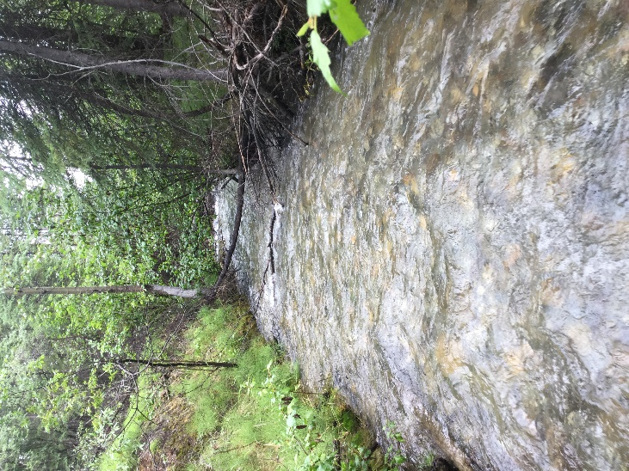 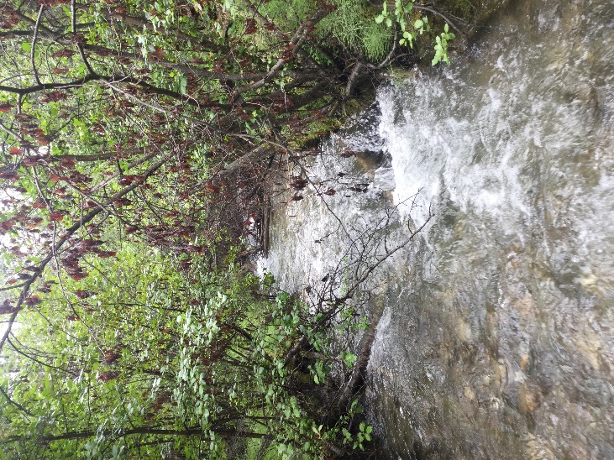

**Cottonwood Trib Site 1: Proposed Site**

This location was very swift and water was high, we checked a few places and decided the easiest would be where we currently have a staff gauge installed.

20m up from where creek drains into Cottown wood river

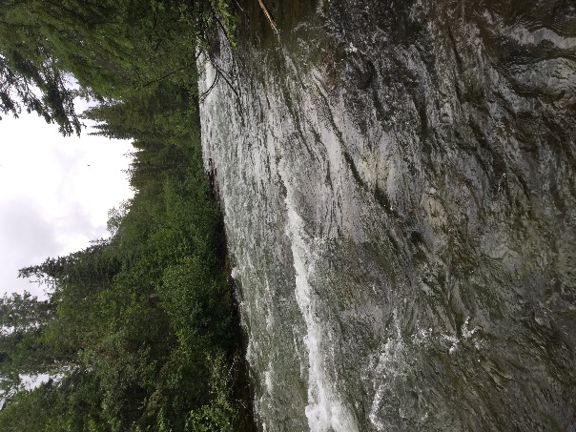 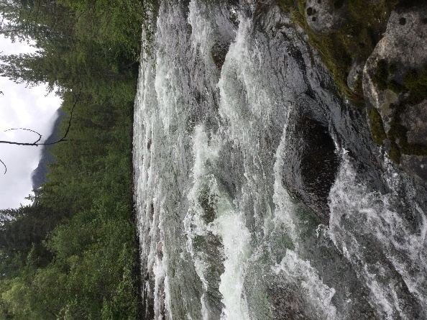

**Cottonwood Trib Site 2: Suggested Location: 59 9.598 -129 50.093**

Looking upstream Downstream Across

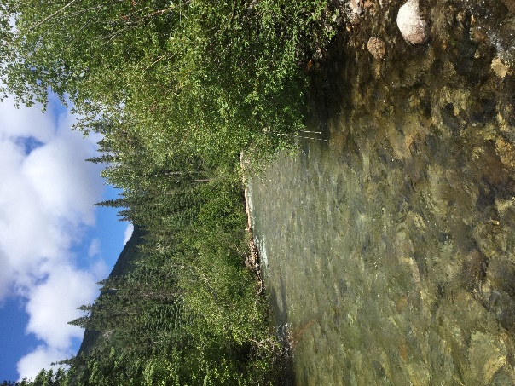 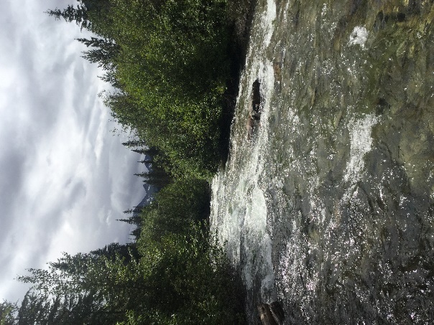 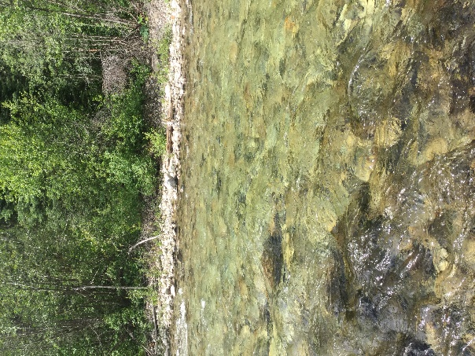

**Simmons Creek Site 1:**

Site was accessed by boat from Simmons Lake **Proposed Location Location was starting to go uphill, middle picture shows 2 other drainages coming into the creek, water was swift and lots of boulders throughout.**

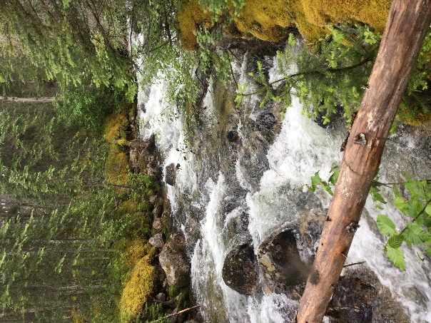 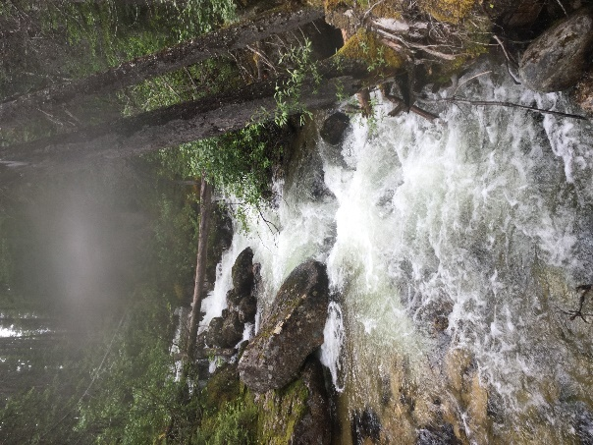 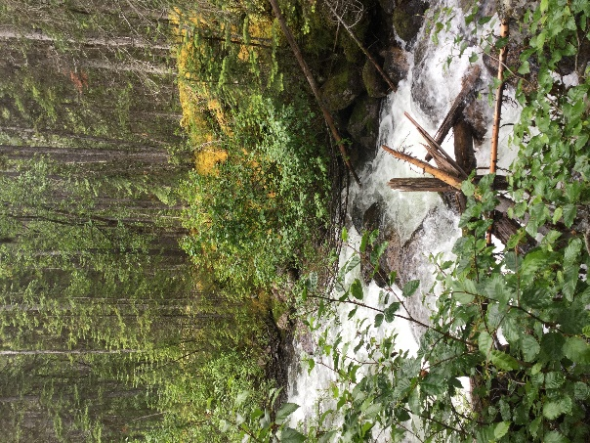

**Simmons Creek Mouth of creek where flows into Simmons Lake, Site 2: 59 11.012 -129 46.957 Suggested Location, mouth of the creek only area we could find that was straight and not as many boulders or swift water. Lots of trees and willows covering creek**

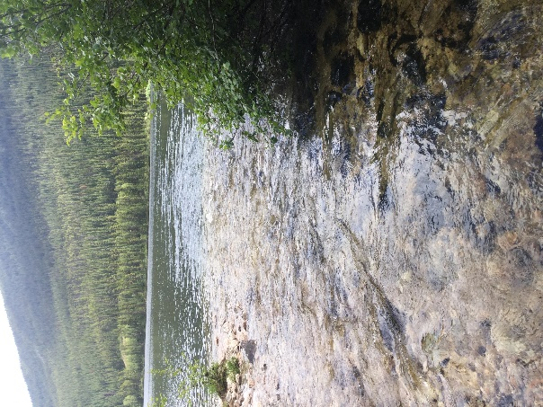 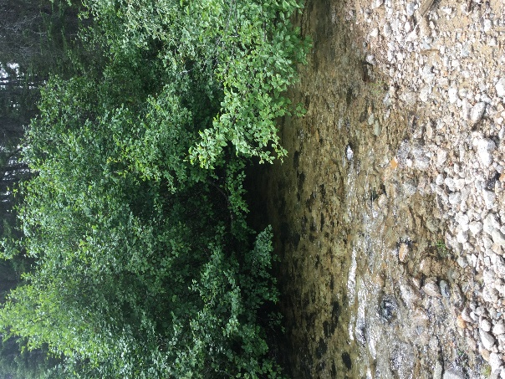 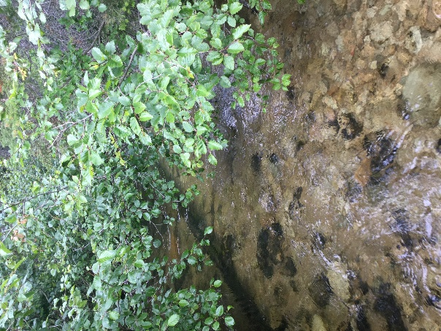

**Quart Rock: 59 17.282 -129 42.832**

100m upstream from propsed site, 2 samll drainages were at proposed location.

Looking Upstream Downstream

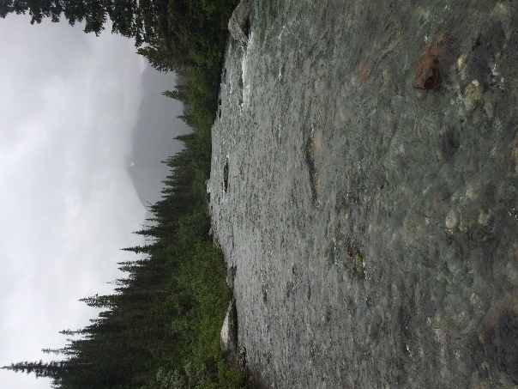 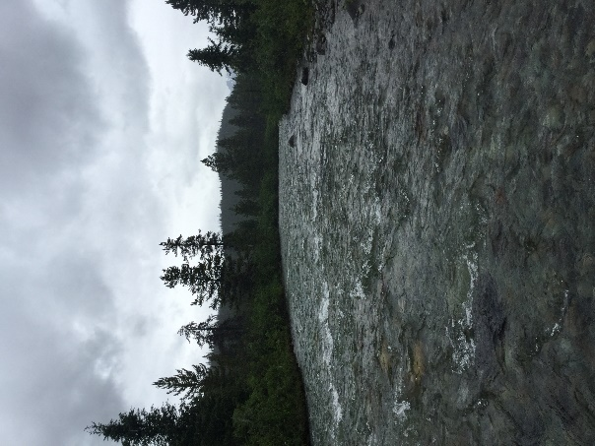

**Bass Creek was not located area was to grown in and creek was to deep to cross**